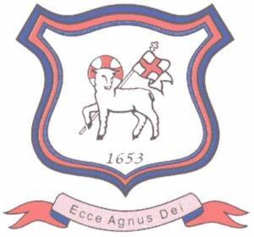
BRETHERTON ENDOWED CE
PRIMARY SCHOOL
South Road
Bretherton
Lancashire
PR26 9AH
Tel/Fax (01772) 600431
Email: head@bretherton.lancs.sch.uk

Walking in the footsteps of Jesus with our Christian family, we learn, grow, achieve and flourish together in God’s love.

December 2021

Dear Parents,

Your child is on our asthma register as having been diagnosed with asthma. We would like to ask you to provide further information to ensure that we can support them better in school, in the type of things that can affect them specifically and medication doses required.

We would like to ask you to complete the asthma card suggested from the Asthma UK website and would also ask you to consult your child’s GP if you need any clarification as to what to add. We will use this card as our basis of care in school.

Under Government legislation we are able to hold a spare salbutamol inhaler in school in the event of an emergency. We have created an Appendix to our Asthma Policy to support this and would like to ask for your permission to use the spare in the event of your child not having their inhaler in school for any reason. I have attached the Asthma Policy and Appendix for your information and the permission form to be returned to school by Friday 17th December.

Thank you in advance for completing these documents and don’t hesitate to contact the school office should you have any questions.

Kind regards,

Yours sincerely

Mrs Moxham

Mrs A Moxham
Head Teacher



Headteacher : Mrs Alison Moxham Chair of Governors : Mr T. G. Wilson www.brethertonschool.org.uk

