BRETHERTON ENDOWED CE
PRIMARY SCHOOL
South Road
Bretherton
Lancashire
PR26 9AH
Tel/Fax (01772) 600431
Email: head@bretherton.lancs.sch.uk

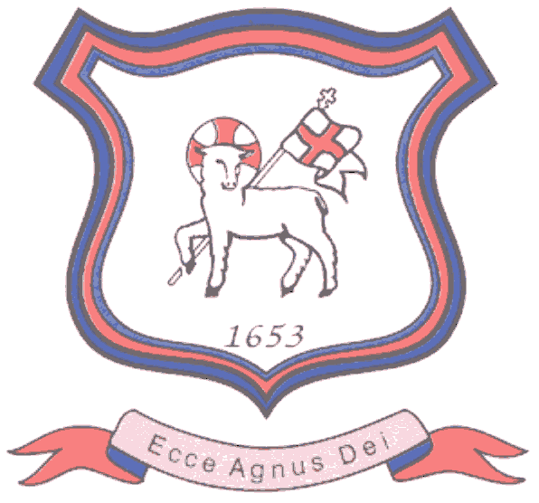

Walking in the footsteps of Jesus with our Christian family, we learn, grow, achieve and flourish together in God’s love.

16/4/24.

Dear Parents,

As a part of your child’s education at Bretherton, we promote personal wellbeing and development through a comprehensive Personal, Social, Health and Economic (PSHE) education programme which is underpinned by our Christian values. We truly believe that PSHE education is a vital curriculum subject that gives children the knowledge, understanding, attitudes and practical skills to live safe, healthy, productive lives and meet their full potential.

I am writing to let you know that during this Summer term, your child’s class will be taking part in lessons which will focus on the relationships and sex education (RSE) aspect of this programme.

Relationships and Health Education is a compulsory part of the curriculum in all primary schools in England. The DFE state quite rightly that:

“Today’s children and young people are growing up in an increasingly complex world
and living their lives seamlessly on and offline. This presents many positive and
exciting opportunities, but also challenges and risks. In this environment, children
and young people need to know how to be safe and healthy, and how to manage their
academic, personal and social lives in a positive way.”
(DfE, 2019, Relationships Education, Relationships and Sex Education and Health Education)

We will be teaching using materials from our PSHE scheme: Jigsaw, which offers a mindful approach to PSHE. The expectations of the DfE Relationships and Health Education guidance are woven throughout Jigsaw but specifically covered in the Relationships and Healthy Me unit, with puberty and human reproduction being taught in the Changing Me Puzzle. We ensure that all aspects of compulsory Relationships and Health Education are covered in a sensitive, spiral, age-appropriate curriculum. PSHE education is taught throughout the school in every year group and is monitored and reviewed regularly by the staff and governing body. All PSHE teaching will take place in a safe learning environment and is underpinned by our school ethos and values.

What does Relationship Education include?

For Primary aged children the content of relationship education includes:
- Families and people who care for me
- Caring Friendships
- Respectful Relationships
- Online Relationships
- Being safe

As part of our learning about respectful relationships and being safe we are participating in the NSPCC’s Speak out. Stay safe. programme this term. Speak out. Stay safe. is a programme for children aged 5-11 which aims to help children understand abuse in all its forms and to recognise the signs of abuse. Children are taught to speak out if they are worried, either to a safe adult or Childline. Please see more information relating to this in the separate letter attached.

What will my child actually be taught about puberty and human
reproduction?

Jigsaw’s ‘Changing Me’ unit will be taught in a way that is age appropriate and
builds on the previous years’ learning. Due to having mixed age classes, some lessons will be arranged so that year groups can be taught separately when the content is not deemed aproppriate for the whole class.

The Changing Me Puzzle is all about coping positively with change and includes:
Ages 3-5 Growing up: how we have changed since we were babies.
Ages 5-6 Boys’ and girls’ bodies; correct names for body parts.
Ages 6-7 Boys’ and girls’ bodies; body parts and respecting privacy (which parts of the
body are private and why this is).
Ages 7-8 How babies grow and how boys’ and girls’ bodies change as they grow older.
Introduction to puberty and menstruation.
Ages 8-9 Internal and external reproductive body parts. Recap about puberty and
menstruation. Conception explained in simple terms.
Ages 9-10 Puberty for boys and girls in more detail including the social and emotional
aspects of becoming an adolescent. Conception explained in simple biological terms.
Ages 10-11 Puberty for boys and girls revisited. Understanding conception to the birth
of a baby. Becoming a teenager.

All lessons are taught using correct terminology, child-friendly language and diagrams.

At Bretherton, we believe that good quality SRE is an important part of safeguarding children,
as knowledge empowers them, helping them to stay safe, cope with puberty and understanding why their bodies will change.

For further information see our PSHE and SRE Policy (attached).

If after reading the policy, you have any questions then please do not hesitate to contact me.

Yours sincerely,

Sarah Allchurch

PSHE Subject Lead

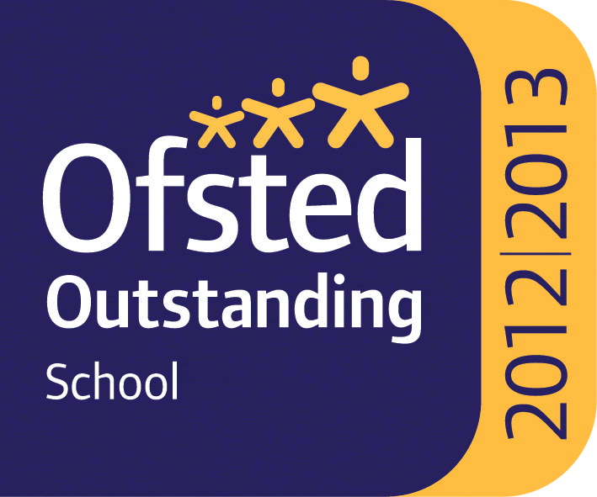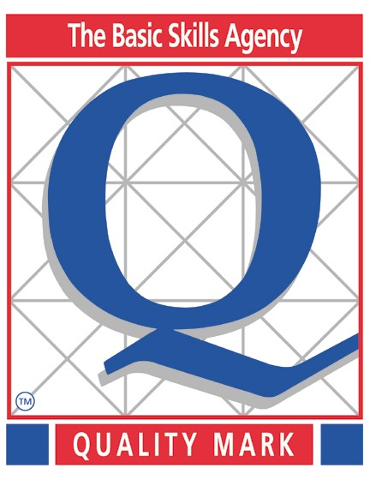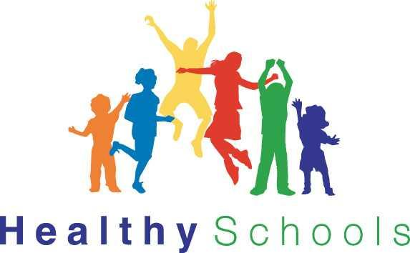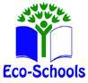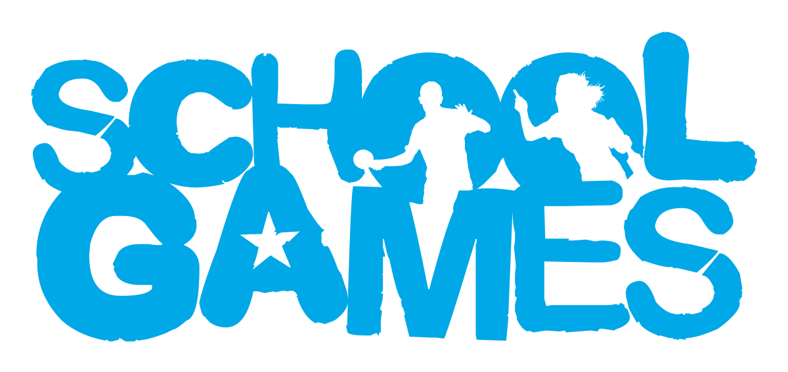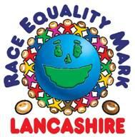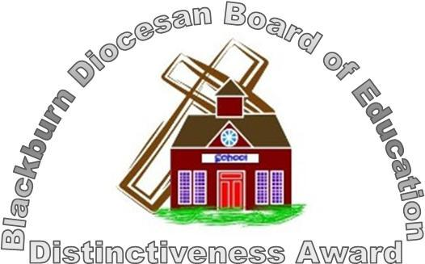

Headteacher : Mrs Alison Moxham Chair of Governors : Mr T. G. Wilson www.brethertonschool.org.uk

