Harvest Assembly 2022 Ethos
Come into Autumn Days

_____________________ Welcome to our Harvest service. Welcome to our school, special visitors and parents.

_____________________We are gathered here today to celebrate harvest festival together, and we would like to invite you to think about how we can create a community in our world; a world where we want everyone to have all that we need for life. Around the world, people may be poor or hungry. They may not have clean water to drink, to cook with and, especially in this time of COVID, people may not have clean water to wash their hands regularly so as to keep healthy. Their environment may be under threat, a threat caused as farms expand to service wasteful lifestyles. ( slide 2)

___________________We are all here today to thank God for creation and to remind ourselves of the importance of safeguarding our beautiful world. We want to work together to protect our environment by considering our actions and making changes that will be sustainable. We gather today to say thank you for all we have and to recognise that we should share with others so they have enough to eat and drink, so that they can remain healthy and go to school and learn – all things that we can take for granted so often. ( slide 3)

_____________________We especially want others to know that we care for them and are thinking and praying for them because we love God and want others to see and feel his wonderful gifts. ( slide 4)

_____________________In our school, we have our own garden where we sow seeds and plant bulbs. It makes us happy to see how well the plants are growing. We like taking care of our beautiful world for us all to enjoy. Our Gardening club gives their time to water and take care of our school garden.

_______________________-Please stand to sing our celebration song to say thanks for our food this harvest time.

SING : Cabbages and Greens ( words on screen)

( slide 6)___________________Thank you, please be seated. Our reading comes from Psalm 65 V:9 -12 You show your care for the land by sending rain; you make it rich and fertile. You fill the streams with water; you provide the earth with crops. This is how you do it: you send abundant rain on the ploughed fields and soak them with water; you soften the soil with showers and cause the young plants to grow. What a rich harvest your goodness provides! Wherever you go there is plenty. The pastures are filled with flocks; the hillsides are full of joy.

_____________________ At harvest time we say thank you to God for the safe gathering in of the harvest. But at harvest time it’s also important to say thank you to the farmers who grow the food for everyone. Farmers do an incredibly important job and without them our world would be in a terrible mess.

______________________ Harvest time always comes in the autumn. All around us we can see the signs that autumn is here. The hot summer days are over as the weather has become colder and windier. The days are getting shorter and the nights are getting longer.

( slide 7)_______________________The leaves on the trees are turning brown and are falling to the ground, making crunching noises beneath our feet as we trample on them. But some bushes and trees are starting to bear fruit now. Blackberries for example are lovely and juicy to eat.

_______________________ A farmer sows the seeds early in the year and then many months later, when those seeds have grown into plants, the farmer reaps in his harvest. The bible says that in life, we all reap what we sow. For example, when we meet new people, if we sow seeds of friendship by being friendly, kind and caring, then we’ll have lots of friends. But if we sow seeds of hurt, cruelty and unpleasantness, we won’t end up with many friends at all!

___________________We would like to share an important message from the bible that encourages us to share our things with others, not just when we have more than we need, but even when we don’t have a lot to share. This is the story of Elijah and a widow. ( slide 8)

( Narrator)____________________Elijah was a man who knew God, talked to God and did what God told him to do. One day God told Elijah to go to a town called Zarephath, and to stay with a lady and her son there. When Elijah got to Zarephath he saw the woman coming towards him. She was collecting sticks to burn on her fire.
(Elijah)______________________‘Please give me a drink of water,’ ‘and some bread to eat.’

( woman)_______________________‘I have no bread,’. ‘There is just enough flour in my bowl and oil in my jar to make one last meal for me and my son, and then we will die because we have no more food.’

( Narrator)______________________There had been no rain there for a very long time and now there was very little food for everyone.

( Elijah)________________‘Don’t worry,’ . ‘Just make your meal, but first make a small loaf for me. God says that until it rains again, there will always be enough flour in the bowl and oil in the jar.’

( Narrator) __________________The lady did as Elijah said. She shared her meal by making some bread for him and then some for herself and her son. Every time she made the bread, there was always enough flour and always enough oil. From the day until it rained again, they had just enough food to eat.

__________________ Have you ever followed Elijah’s words? The lady had almost nothing left, but she shared it with Elijah, and God was pleased with her. Have you ever found it hard to share something when you have very little of it.

( slide 9) _____________________________Let us pray together at this harvest time. The response is …. Hear our prayer

Dear Lord,
we know that everything is possible with faith and God’s help, and so we pray together:
We pray for world leaders: that they may act with faith and compassion to make the world a brighter and fairer place to live.
Lord in your mercy… Hear our prayer
We pray that we will remember God’s promise to fill us with living water and open our hearts and let him into our lives every moment of every day.
Lord in your mercy… Hear our prayer
We pray for all people throughout the world who hunger and thirst: that they may come to share in the food and water God gives for us all.
Lord in your mercy… Hear our prayer
We pray for our school, our families and our friends: that we may always share what we have and so build a brighter world for all to live in.
Lord in your mercy… Hear our prayer
Amen
(slide 10)__________________ Please stand to sing My Lighthouse
SING: My Lighthouse

( slide 11) ______________ Could I ask children to come out and spell HARVEST. Can you get yourself in order.
Harvest time is about… the EARTH
Ask the volunteers to order themselves so the letters spell ‘earth’. Say that harvest time is about celebrating all the good things the earth provides. The variety of food in the world is staggering. And there is so much of it – enough to feed twice the world’s population. And all this is what is remembered at harvest time – as a gift from God.
__________________ Harvest time is about… SHARE. ( Arrange themselves into the word share) We must follow Jesus’ lead and share the riches of the world with everyone.
____________________ Harvest time is about… HEART (ask them to organise themselves in ‘heart’. ) People need to be willing to share so that everyone in the world has all they need. There needs to be a change of heart – starting with you and me.

____________________ Thank you for sharing in our Harvest Assembly today. Thank you for your donations to a local charity. Your generous donations will help other people in need in our area. They will be gratefully received.
____________________
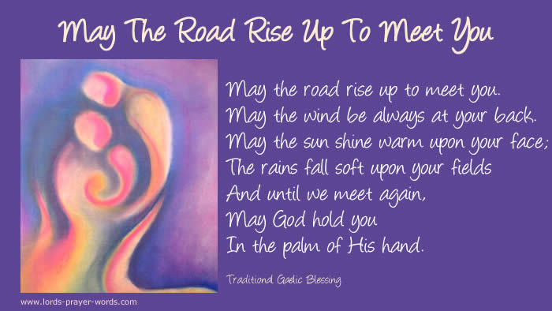
___________________ Before we leave the Chapel today, we would like to invite Mrs Clarke to the front.

Mrs Clarke presents PRESENT THE GIFT, picture AND FLOWERS TO CHRISTINE

__Luke_________ We will end with a Prayer for Pastor Les and Christine and our Grace

Father God,
We give thanks for Pastor Les and Christine,
And the time they have been in our lives,
We are grateful for their example and love.
It’s time for them to leave behind dear friends
As they begin their new adventure
They gave us direction and they have shown a heart to do Your will,
Their work, using their skills and talents, they helped us find ours too.
We are grateful for their ministry and for showing us Your teachings
They’ve planted seeds in us, through your words, and now it’s our time to grow.
Thank you for the joy and laughter and for everything they have done
For our children, school and community, the job, You asked of them, they’ve done
So bless them both with your eternal love and send
them forward into retirement in your light
Thank God for the time we’ve spent with them so we
We thank You for Your true and faithful servants, Christine and Les
Amen.

So may we end our service with End with our Grace

May the grace of our lord ……..

Service ends

