How to add photos to an assignment before submitting when working on a laptop/Chromebook with a webcam.
This method will allow you to upload a number of photos onto one document.
Once the assignment is opened, click on the ‘Add or create’ box.
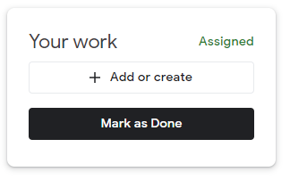
When the drop down box appears click on ‘slides’.
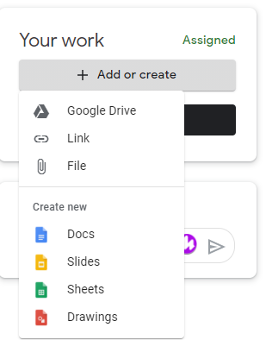
Allow slides to open up. Once the file opens, click on the ‘insert image’ icon on the tool bar. A drop down list will appear, click on ‘camera’. This will allow access to your webcam and may ask you to allow in a pop up box.
The webcam will then show the image in front of it e.g. hold up a completed piece of work. Then click on the ‘take picture’ button.
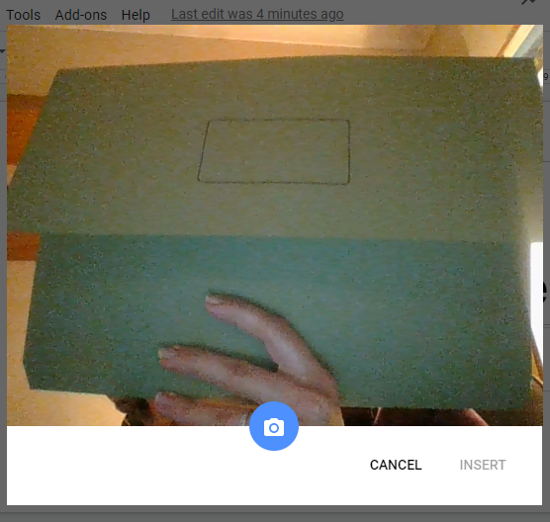
The pictures you take will appear in the panel at the side. Select the first picture you want to add to the slides document and click ‘insert’.
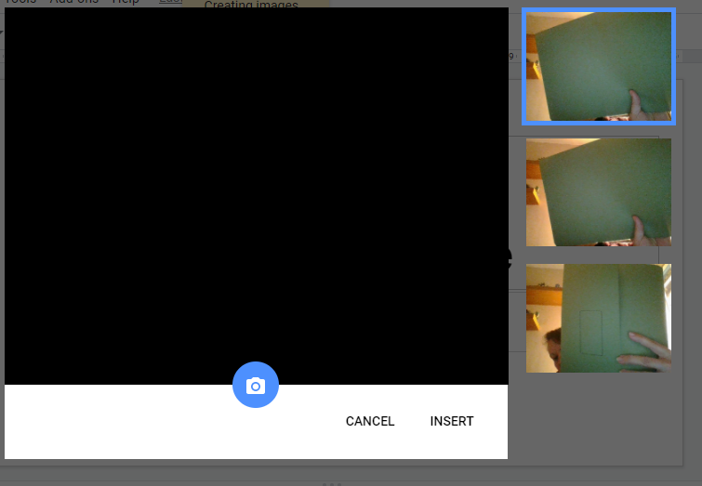

This will add your image to the slide which can then be enlarged.
To add more images to the same document, add a new slide either by clicking on the menu bar ‘Insert’ – ‘New Slide’ or pressing the keyboard buttons ‘CTRL + M’. This will add a new slide. Click on the picture item as before and select the photo you want to insert as they will remain there until you close the document or take a further photo and insert it.

When you have finished adding the photos, close the document using the ‘x’ on the tab at the top. This will automatically save the work.
You will return to the page where you will see a document for google slides and this can be submitted to the teacher by clicking ‘Hand in’.

