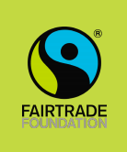
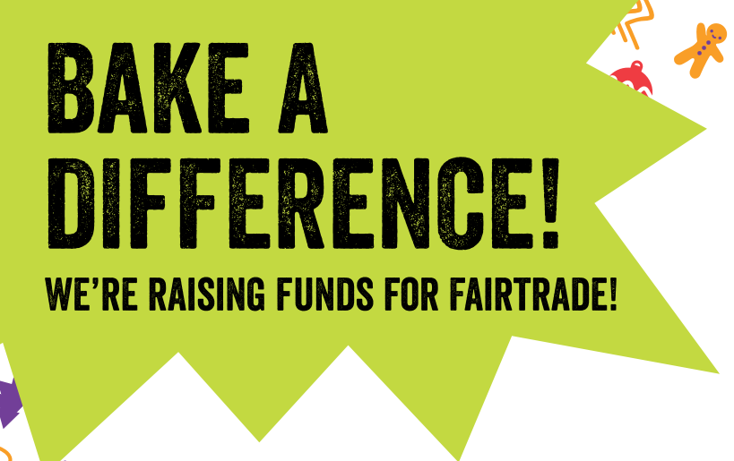

Dear Parents,
The Fairtrade Pupil Voice group are raising awareness of The Fairtrade Association by baking gingerbread people made from Fairtrade ingredients. We will be selling our freshly baked Gingerbread people on Thursday 21st November in school (and any left after school by the hall doors). They will cost £1 and all money raised will go directly to the Fairtrade Foundation.
Together we can ‘Bake a Difference!’
Thank you
Mrs Allchurch and the Fairtrade Pupil Voice Group.

