Bretherton Churches Together
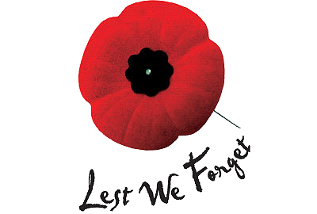
Remembrance Day Service
Sun 12th November at 10.15am
THE CONGREGATIONAL CHURCH BRETHERTON
Followed by service at the War Memorial at 11am
After the service tea and biscuits at the Congregational Church

