Lancashire wide primary school 'Last Choir Singing' competition has successfully completed its seventh year.
The Last Choir Singing Competition, featuring hundreds of Lancashire’s best young singers, had its 2023 Grand Finale on Friday 16th June.
The finale was held at King Georges Hall, Blackburn, featuring ten finalist schools from across the county, including Chorley, Burscough and Fleetwood.
This year the competition had 31 schools taking part in the heats, that were held in March 2023 at various venues across Lancashire. Following the heats, 10 schools made it through to the grand final.
In the final, each choir sang a set song followed by a song of their choice, which were judged by three independent judges; all of which are experts in the music industry.
This year, Bretherton Endowed CE Primary School, took the County Final Winners trophy home, and will receive the grand prize of day in a professional recording studio, where they will be able to record their winning songs. This was the first year that Bretherton had entered the competition and where delighted to take home the winners trophy.
Jayne Clarke, Deputy Head and Choir Leader at the school said “We are so proud of the children in Bretherton Endowed Primary School Choir who shine each day and express themselves through music. The passion of the children, who truly believed in themselves and each other, helped them achieve their dreams and be inclusive to all”.
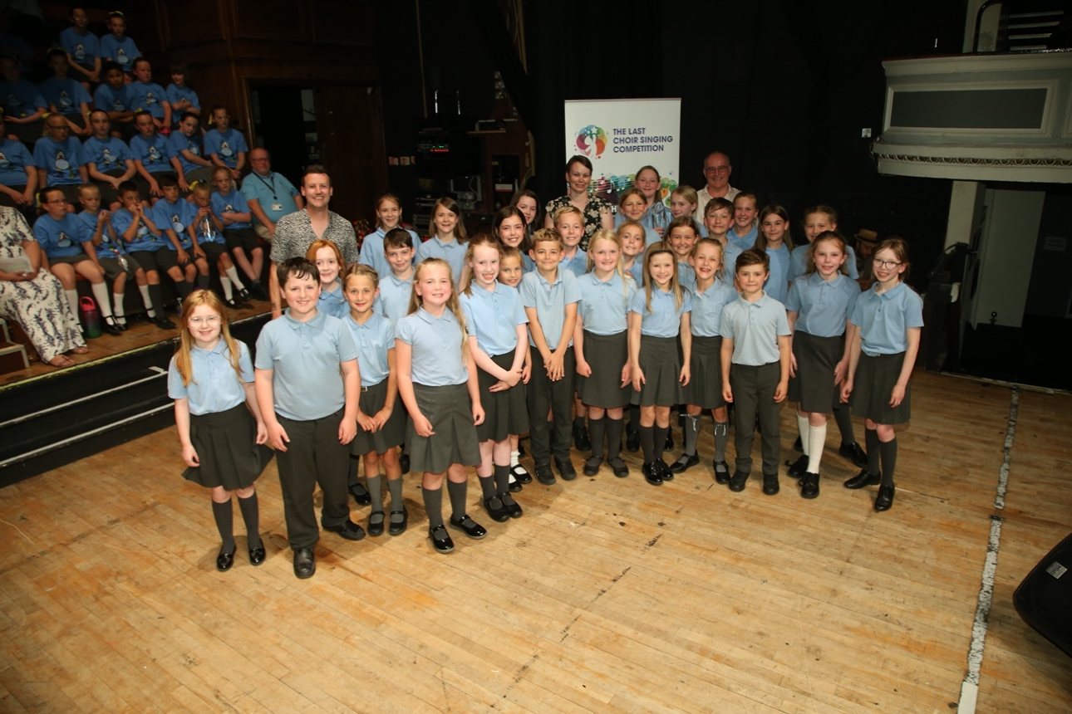
The first runners up were Alston Lane Catholic Primary School, Longridge and second runners up were AKS Lytham Preparatory School, who will receive cash prizes of £250 and £150 respectively.
Meanwhile St Patrick’s RC Primary School, Walton Le Dale won Best Newcomer and Coppull Parish Church School won the Angela Carson Award.
Local businessman George Critchley, who founded The Last Choir Singing, said: “This year we had five schools making it through to the Grand Final, who had entered the competition for this first time this year. Out of those five schools four of them won trophies, including Bretherton who won the overall competition. Its magnificent after seven years to see new choirs still wanting to enter. All the schools who have taken part this year have been fantastic. The choirs have given it their all and should all be so very proud of themselves. We are already excited to start planning the 2024 competition”.
The 10 finalist schools were Park Primary School, Colne; Alston Lane Catholic Primary School, Longridge, AKS Lytham Preparatory School, Anchorsholme Academy, Thornton Clevelys, Norbreck, Thornton Celvelys, Bretherton Endowed CE Primary School, St Patrick’s PC Primary School, Walton Le Dale, Coppull Parish Church School, Chorley, Lordsgate Township C of E Primary School, Burscough, St Mary’s RC Primary, Osbaldeston and Park primary School, Colne.
The 2024 Last Choir Singing competition will be open for entries in September 2023.
If you would like to know more about the Last Choir Singing, have a look at the website or follow the Facebook page.
